**ODD Protocol**

**OUTLAND: OrangUtan simuLAtioN model**

The model description follows the ODD (Overview, Design concepts, Details) protocol for describing individual- and agent-based models (Grimm et al. 2006), as updated by Grimm et al. (2020).

1. **Purpose and patterns**

The Purpose of the model is to simulate the effect of changes in forest structure to the locomotion behaviour of orangutans. The grade of forest changes are defined by the tree density, crown size, and diameter-at-breast-height (dbh). The locomotion behaviour of orangutans to be observed are brachiation, sway, climb / descent, and walking.

1. **Entities, State variables, scales**

Orangutan and trees are the main entities in the model. Link is an entity which is dependant on the state of tree agents. Links are described in the model as a virtual connection between trees. Links are established to assist orangutan agent in their movement decisions. Information that is contained by the links include the distance between trees and the support-type. Support-type defines which locomotor behaviour an orangutan can perform to reach a tree at the other end of the link. It can be sway, brachiate, or climb/walk. The description of each entities in the model are shown in Table 1.

Table 1. List of entities and state variables

|  |  |  |
| --- | --- | --- |
| **Entities** | **State Variable** | **Values and Units** |
| Orangutan | Body-mass | 38 – 100 kg |
|  | Arm-length | 200 – 10000 kCal |
| Tree | Size-category | 0,5 – 1,5 m |
|  | Height | 1 – 5 m |
|  | Crown-width | 15 – 40 m |
|  | Fruit availability | 10 – 40 cm |
| Link | Distance | 1 – 10 m |
|  | Support-type | Sway / brachiation |

To represent the describes setting, the concept of network is used which includes trees as nodes with links in between. The orangutan is represented as an agent which position is on a node and can move along nodes which are connected to each other. The spatial size of simulation is 1 Ha, represented in the model as 100 x 100 grid cells sized 1 square-meter each.

The model represent 20% of orangutan day-time which equals to 144 minutes. One time-step in the model represent one second. Therefore the total simulation length in the model equals to 8640 time-steps in NetLogo.

1. **Process overview and scheduling**

At every timestep, the model checks whether the orangutan is hungry. If orangutan is hungry, then it will go to a fruiting tree. Otherwise, it will select a random non-fruiting tree.

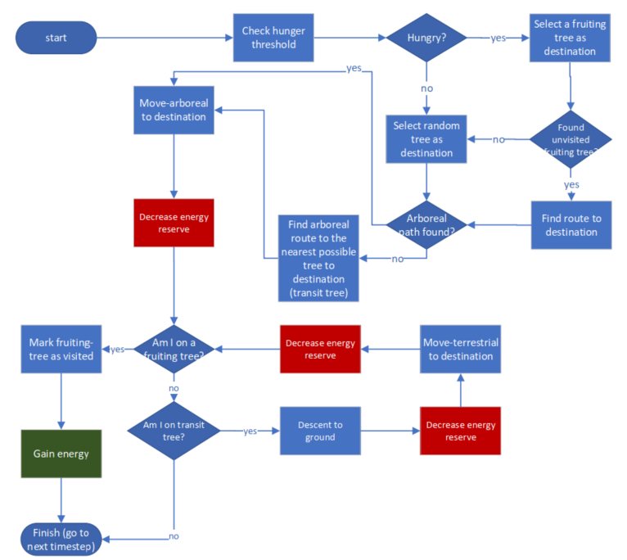

Fig. 1. Flowchart diagram illustrating the process in one timestep in the model